**Progress Report Week 2**

**Group Name: Anhinga**

**Part I: Fiber orientation analysis:**

Exploring the data: The reconstructed micro-CT scan was stored in a scanner native format (.txm). The reconstructed volume has the grid dimensions of $1008×1024×1004$, a voxel size of0.00443597 $4.43597⋅{10}^{-3}×4.43597⋅{10}^{-3}×4.43597⋅{10}^{-3}mm$ (physical unit), and the intensities stored in a uint8 bit-representation in the range from 0 to 64822.

Crop-out: The initial analysis is done in a smaller crop-out of size $400×400×400$. The position of the crop-out is shown in Figure 1.

**Figure 1:** Crop-out from the reconstructed micro-CT scan.

Gradient calculation: The gradients in x and y direction in all voxels are computed using a sobel filter. The results are shown for a selected slice in Figure 2.

**Figure 2:** Slice number 200 from the crop-out along with the gradients in the x and y.

Orientation analysis: The magnitude and the angle relationship between the gradients are computed for every voxel using the following formulas.

* Magnitude: $\sqrt{Vx_{sob}^{2}+Vy_{sob}^{2} }$ 1.41
* Angles: $arctan2{(Vy_{sob}},Vx_{sob})$ 3.14

The angles are converted to an RGB colormap, and both the magnitude and angular maps are exported for visualization using ITK-SNAP (see Figure 3).

**Figure 3:**Example of slice (200): Left: Gradient magnitude, Right: Gradient direction.

We classify a voxel as either being horizontal or vertical if:

* The gradient magnitude is above 16000
* The angle is +/- 0.5 / [1,2] radians from the respective vertical / horizontal axis.

The volumes and volume ratio are determined, and the classification result is visualized in Figure 4.

The volume of horizontal fibers: 0.2834

The volume of vertical fibers: 2.213

The ratio: Empty: 35398820, h: 3247195, v: 25353985

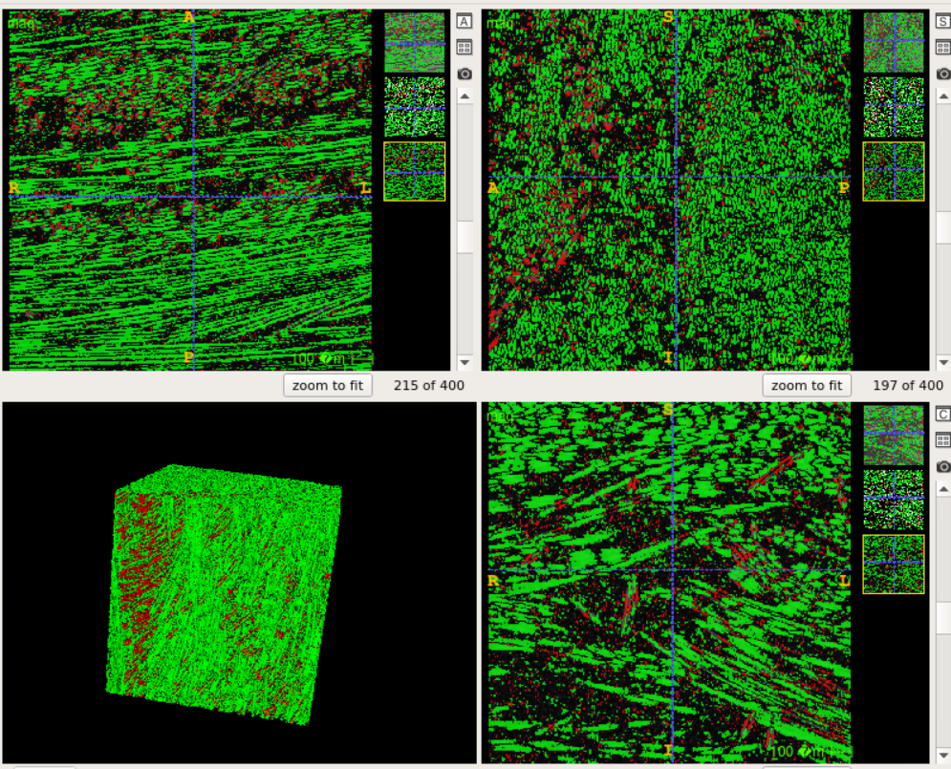

**Figure 4:** Segmentation results

**Part II.I: CUB_200_2011 - bird classification using CNN:**

Exploring the data: The CUB_200_2011 is an open benchmark dataset consisting of 11788 natural images of 200 classes of birds. A few example images are given in Figure 5.

**Figure 5:** Example image from train - and test loader.

Data transforms: The input images have varying dimensions and aspect ratios. We therefore apply the following data transforms to standardize the input: padding, normalization, resizing & cropping.

Testing a CNN model for classification: The model consists of X. Describe the network model and other hyper-parameter choices (activation functions, loss functions, optimizer, batch size, epochs).

The training and test loss curves are shown in Figure 6. We see that describe the result (e.g. final accuracy).

**Figure 6:** Provide an appropriate figure caption.

**Part II.II: Bird classification using CNN and data augmentation:**

Dataset: CUB_200_2011 **or** DTUB_213_F24.

The CNN model is identical to the described in Part II.I. The difference is that data augmentation is applied to the training images. The following augmentation transforms are applied:

* X
* X
* X

The training and test loss curves are shown in Figure 6. We see that describe the result (e.g. final accuracy, overfitting) in comparison to Part II.I.

**Figure 6:** Provide an appropriate figure caption.

Performance analysis on class x: The prediction accuracy on birds from class x was x. Examples of misclassified test images from the class are shown in Figure 7. The class is often? mistaken for class x. Describe if there is a pattern in the misclassifications (e.g. are they classified as a similar looking bird species?)

**Figure 7:** Provide an appropriate figure caption.